

**WEB TECHNOLOGIES**

**LAB ASSIGNMENT 04**

**NAME:**

**MUHAMMAD MUAAZ SHOAIB**

**REG. NO:**

**FA20-BCS-074**

**CLASS:**

**BCS-6B**

**SUBMITTED TO:**

**MR. TABISH**

**DATE:**

**07-JUNE-2023**

**Question 1:**

**Write a Program to display count, from 5 to 15 using PHP loop.**

<?php

for ($i = 5; $i <= 15; $i++) {

echo $i . "\n";

}

?>

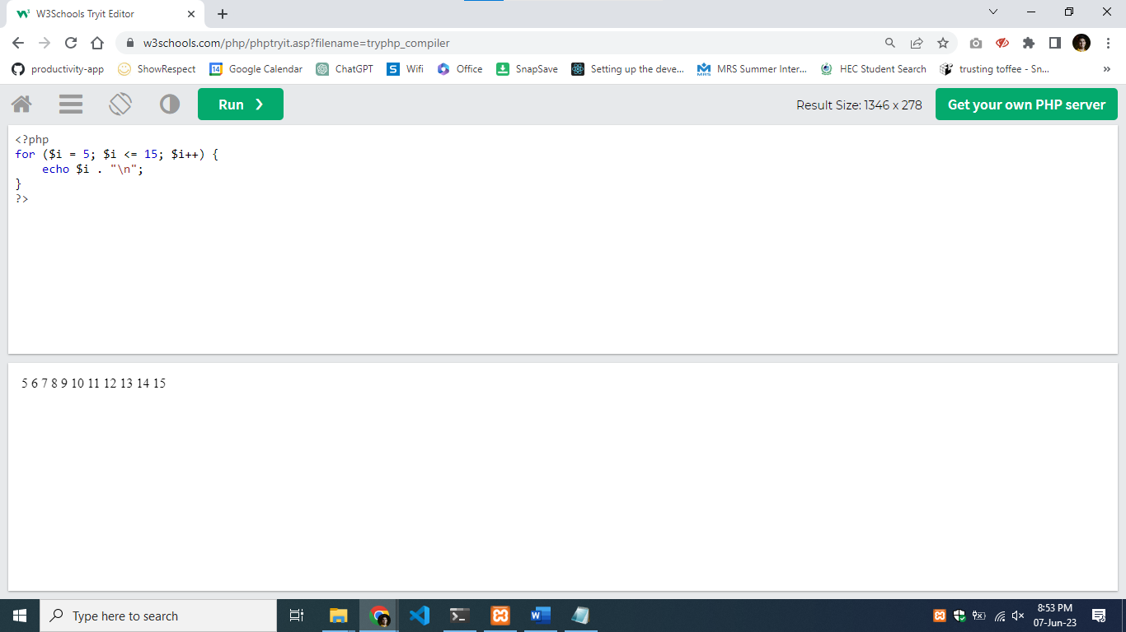

**Question 2:**

**Write a program to check student grade based on the marks using if-else statement.**

**Conditions:**

**1. If marks are 60% or more, grade will be First Division.**

**2. If marks between 45% to 59%, grade will be Second Division.**

**3. If marks between 33% to 44%, grade will be Third Division.**

**4. If marks are less than 33%, student will be Fail.**

<?php

$marks = 75;

if ($marks >= 60) {

$grade = 'First Division';

} elseif ($marks >= 45 && $marks <= 59) {

$grade = 'Second Division';

} elseif ($marks >= 33 && $marks <= 44) {

$grade = 'Third Division';

} else {

$grade = 'Fail';

}

echo "Marks: " . $marks . "\n";

echo "Grade: " . $grade . "\n";

?>

**Question 3:**

**Write a program to show a day of the week (for example: Monday) based on numbers using switch/case statements.**

**Conditions:**

**1. You can pass 1 to 7 number in switch**

**2. Day 1 will be considered as Monday**

**3. If the number is not between 1 to 7, show invalid number in default.**

<?php

$dayNumber = 3;

switch ($dayNumber) {

case 1:

$day = 'Monday';

break;

case 2:

$day = 'Tuesday';

break;

case 3:

$day = 'Wednesday';

break;

case 4:

$day = 'Thursday';

break;

case 5:

$day = 'Friday';

break;

case 6:

$day = 'Saturday';

break;

case 7:

$day = 'Sunday';

break;

default:

$day = 'Invalid number';

break;

}

echo "Day Number: " . $dayNumber . "\n";

echo "Day: " . $day . "\n";

?>

**Question 4:**

**Write a PHP program using nested for loop that creates a chess board.**

**Conditions:**

**1.You can use html table having width=”400px” and take “30px” as cell height and width for check boxes.**

<!DOCTYPE html>

<html>

<head>

<style>

table {

width: 400px;

}

td {

width: 30px;

height: 30px;

}

.black {

background-color: #000;

}

.white {

background-color: #fff;

}

</style>

</head>

<body>

<table>

<?php

for ($row = 1; $row <= 8; $row++) {

echo "<tr>";

for ($col = 1; $col <= 8; $col++) {

$class = ($row + $col) % 2 == 0 ? "black" : "white";

echo "<td class='$class'></td>";

}

echo "</tr>";

}

?>

</table>

</body>

</html>

**Question 5:**

**You need to write a PHP program to calculate electricity bill using ifelse conditions.**

**Conditions:**

**1. For first 50 units – Rs. 3.50/unit**

**2. For next 100 units – Rs. 4.00/unit**

**3. For next 100 units – Rs. 5.20/unit**

**4. For units above 250 – Rs. 6.50/unit**

**5. You can use conditional statements.**

<?php

$units = 300; // Number of units consumed

$totalBill = 0;

if ($units <= 50) {

$totalBill = $units * 3.50;

} elseif ($units <= 150) {

$totalBill = (50 * 3.50) + (($units - 50) * 4.00);

} elseif ($units <= 250) {

$totalBill = (50 * 3.50) + (100 * 4.00) + (($units - 150) * 5.20);

} else {

$totalBill = (50 * 3.50) + (100 * 4.00) + (100 * 5.20) + (($units - 250) * 6.50);

}

echo "Total Electricity Bill: Rs. " . $totalBill;

?>

